1. Create one vpc in North Virginia region.

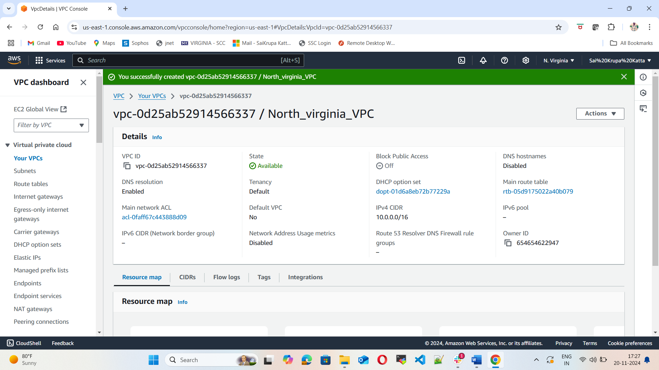

2) Create two subnets.

One Public subnet and one private subnet.

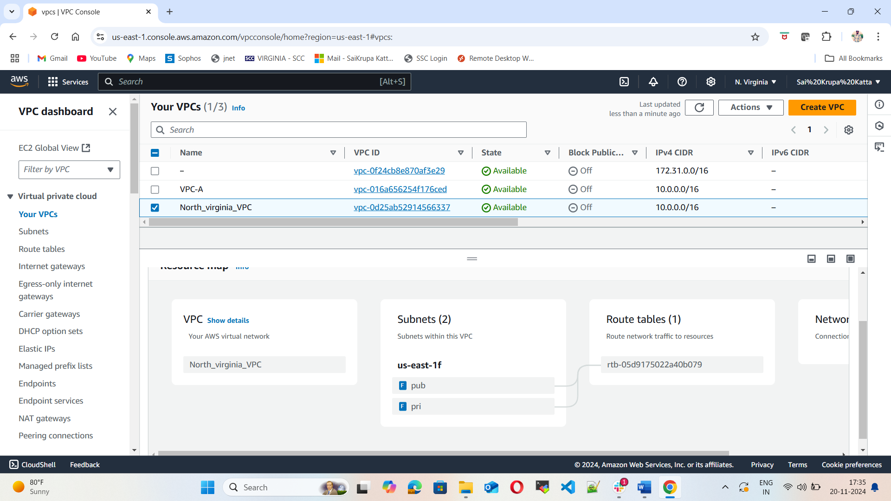

1. Provide the IGW to the vpc.

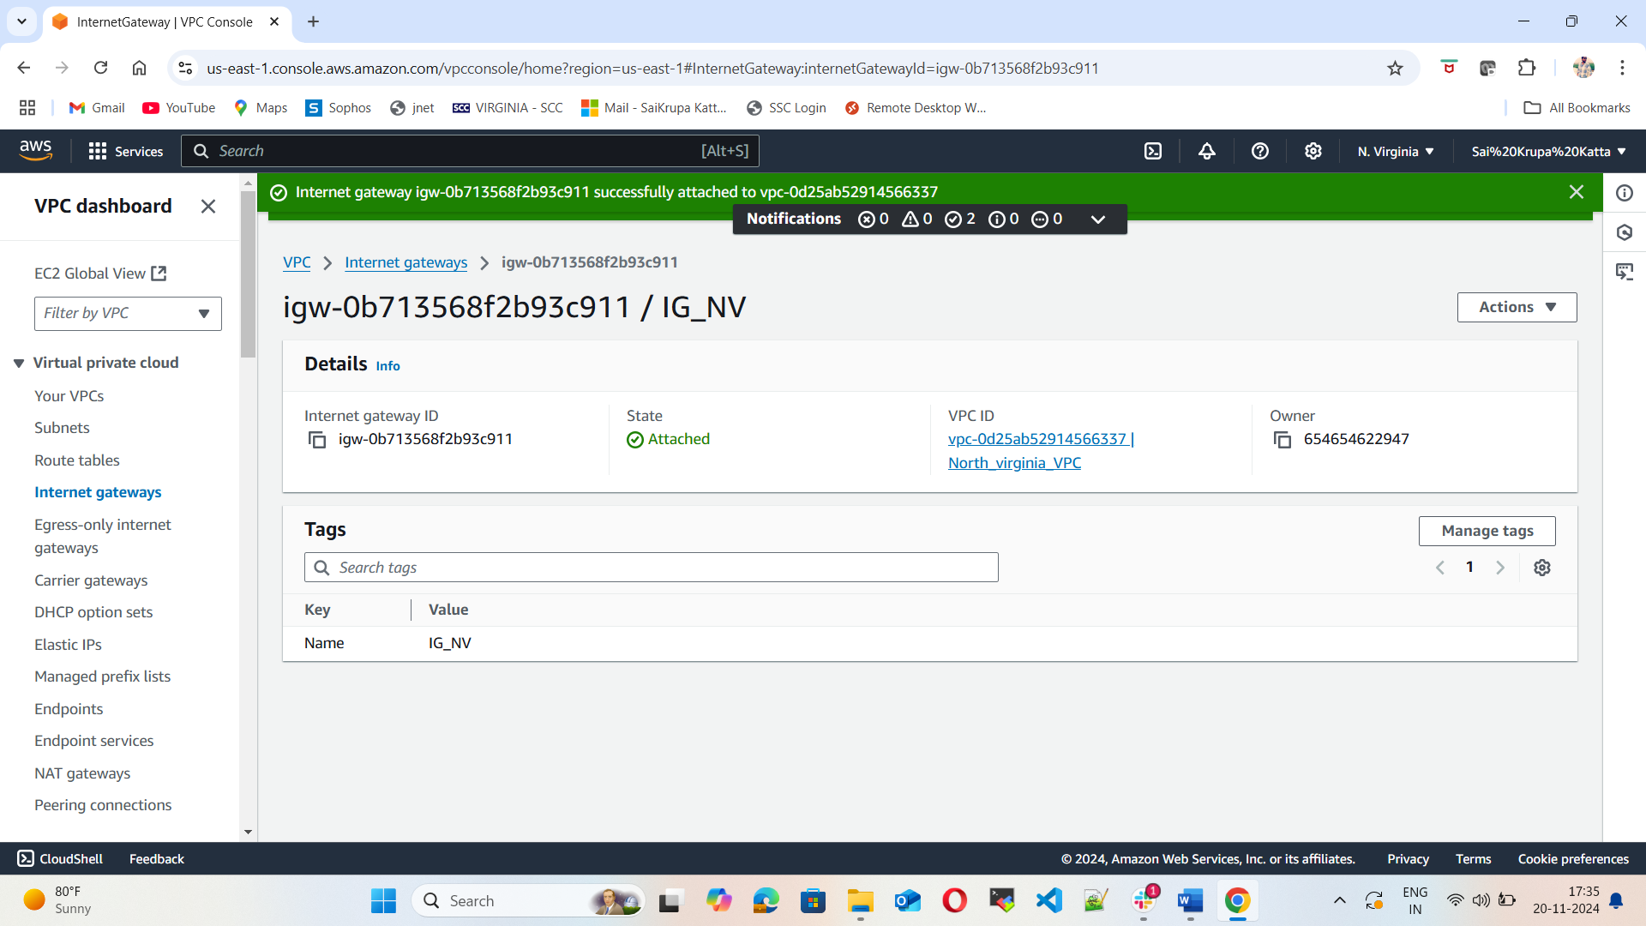

1. Create One public RT and one private RT.

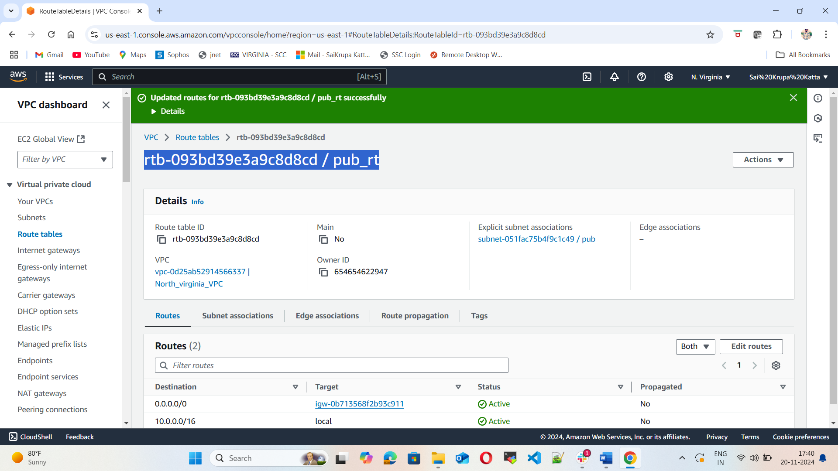

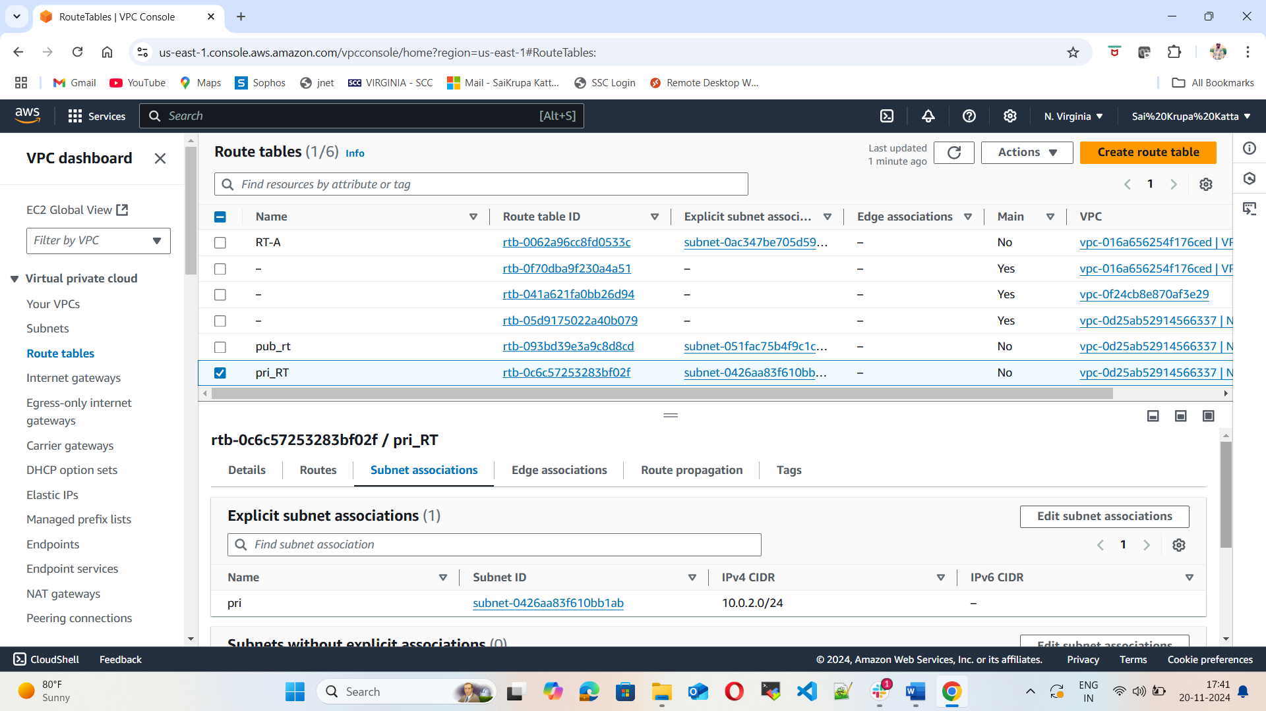

1. Deploy NAT gateway on public subnet and attach the NAT gateway to private subnet.

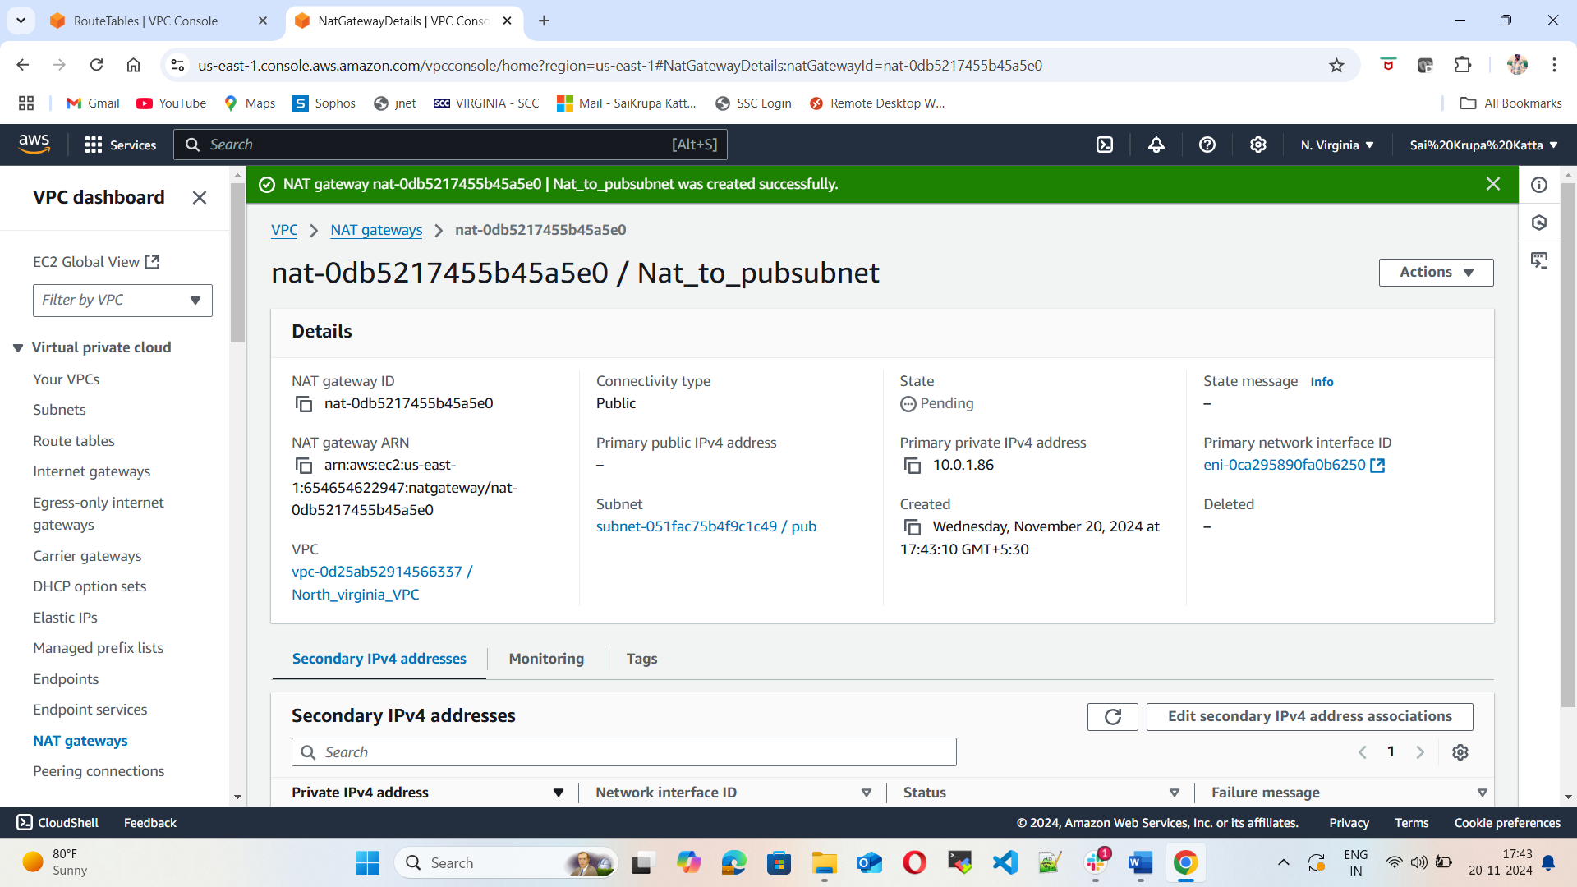

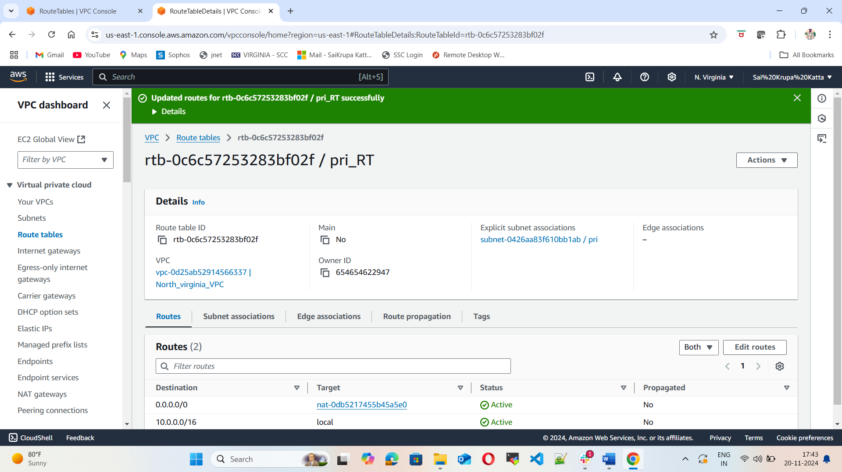

1. Create Two instances, one in public subnet and one in private subnet.



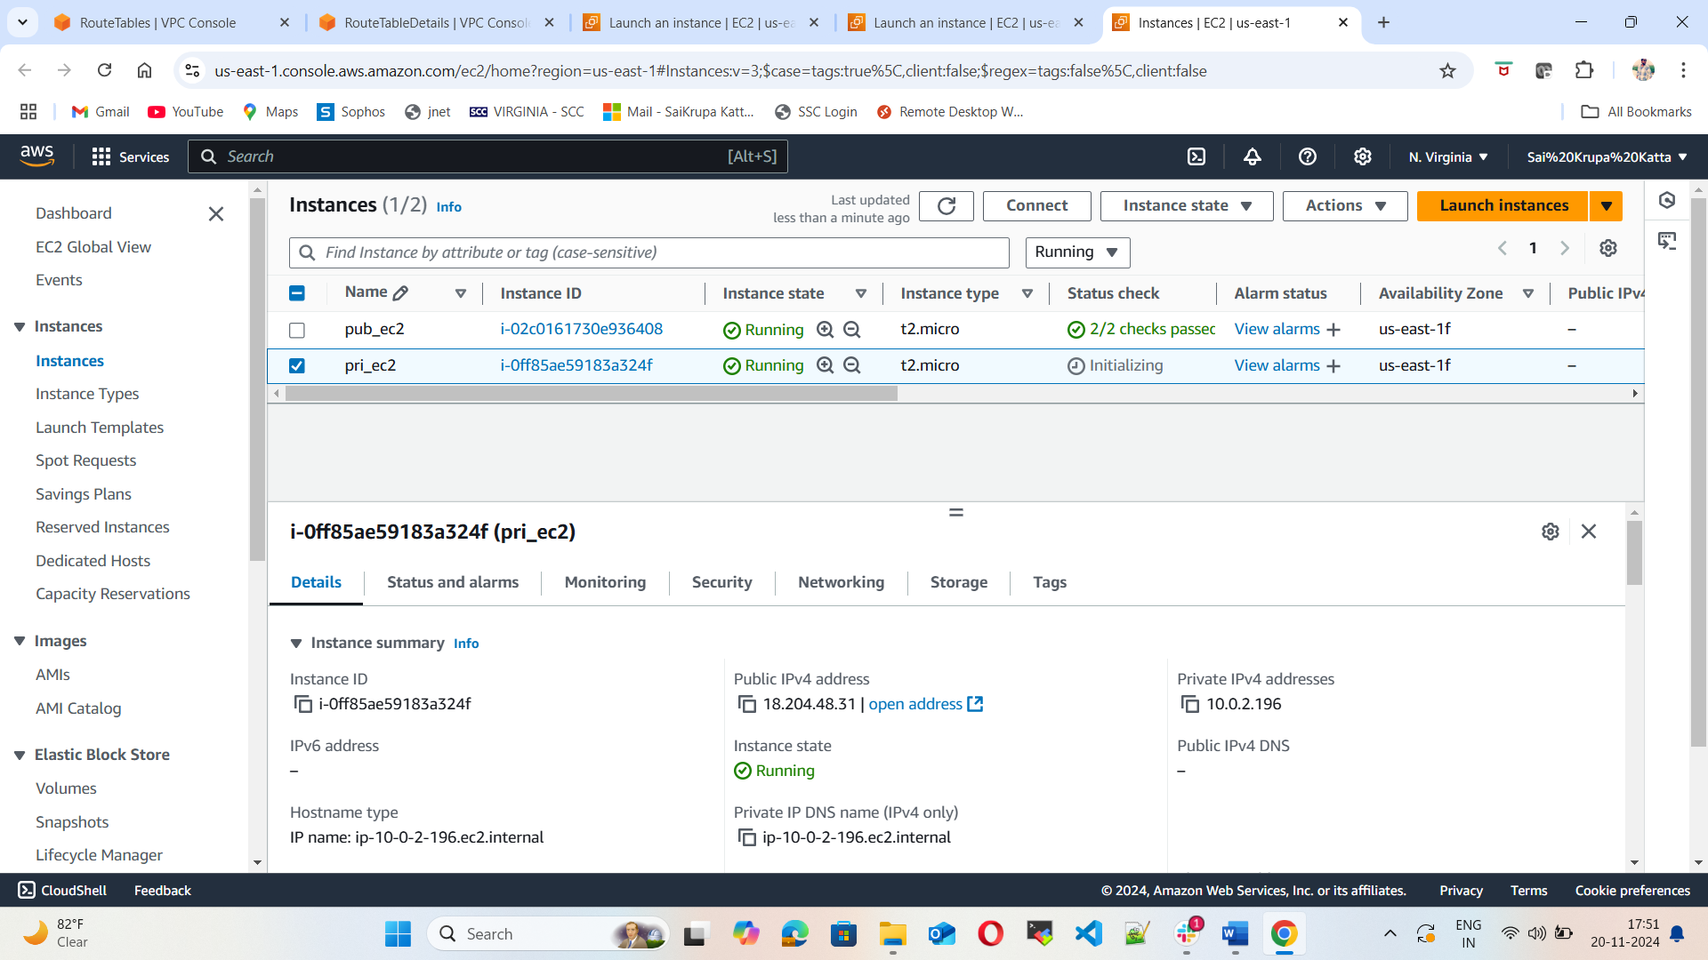

1. Deploy Apache server on both the ec2 instances with sample index.html file.

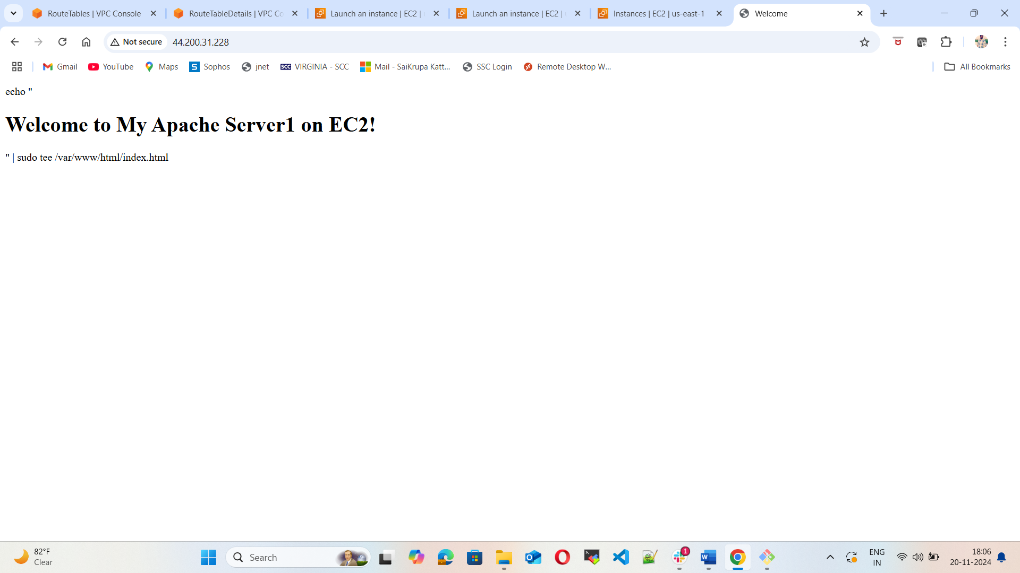

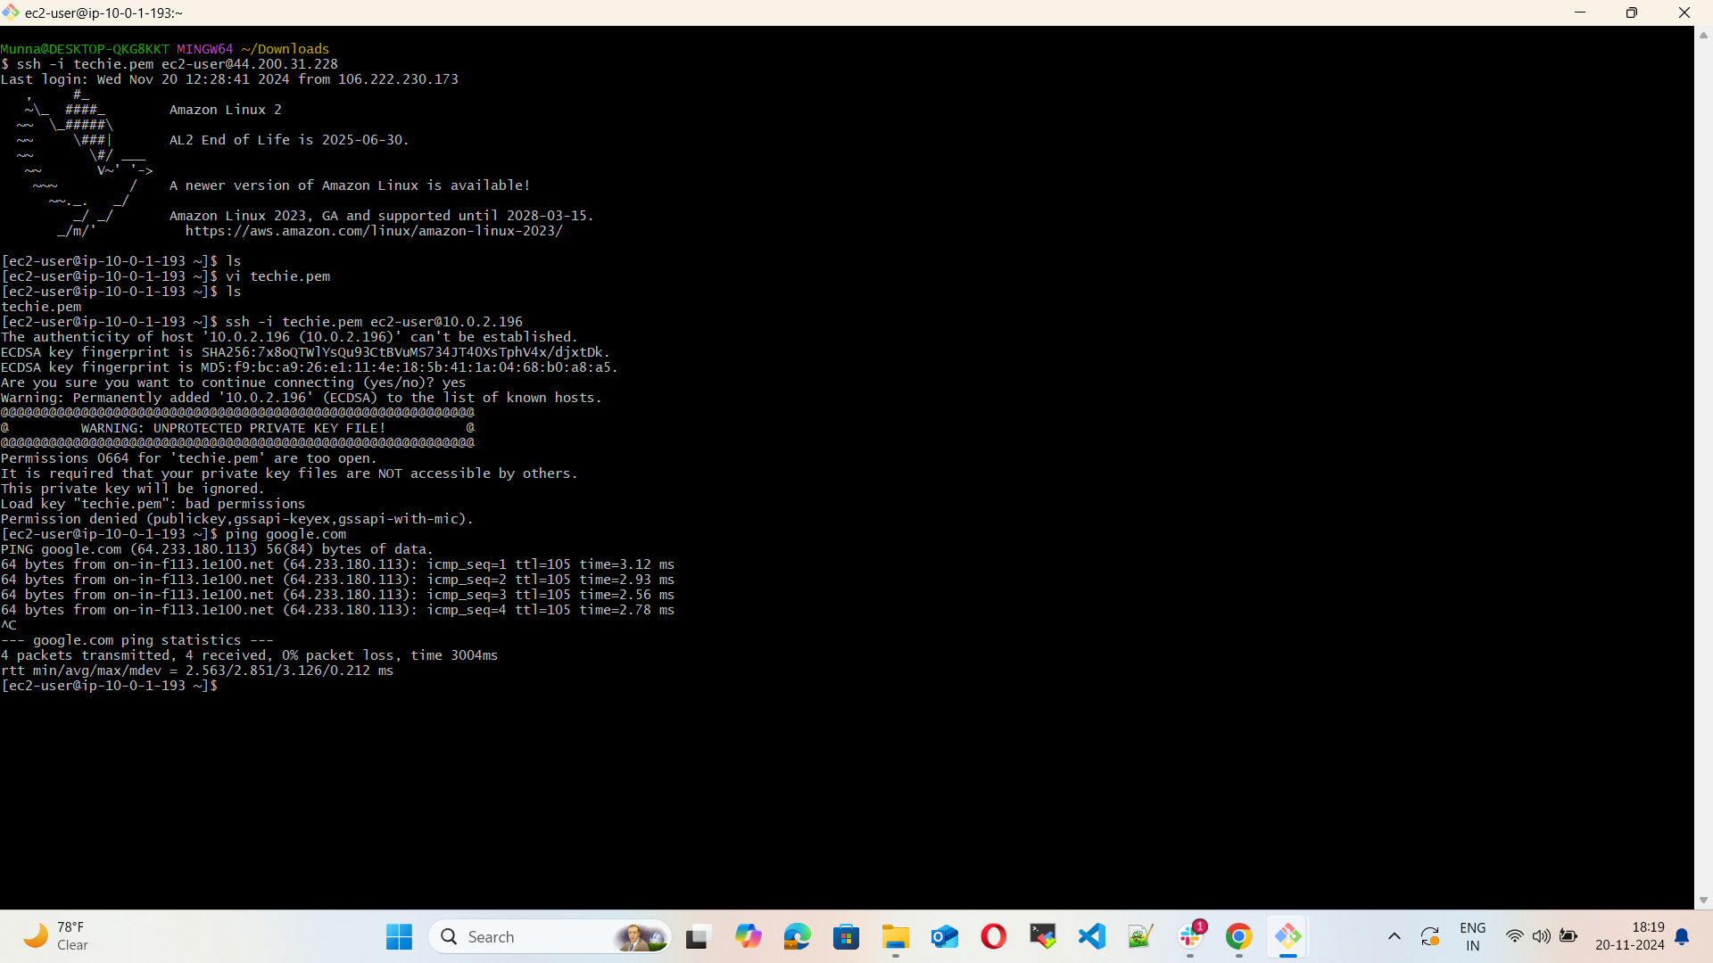

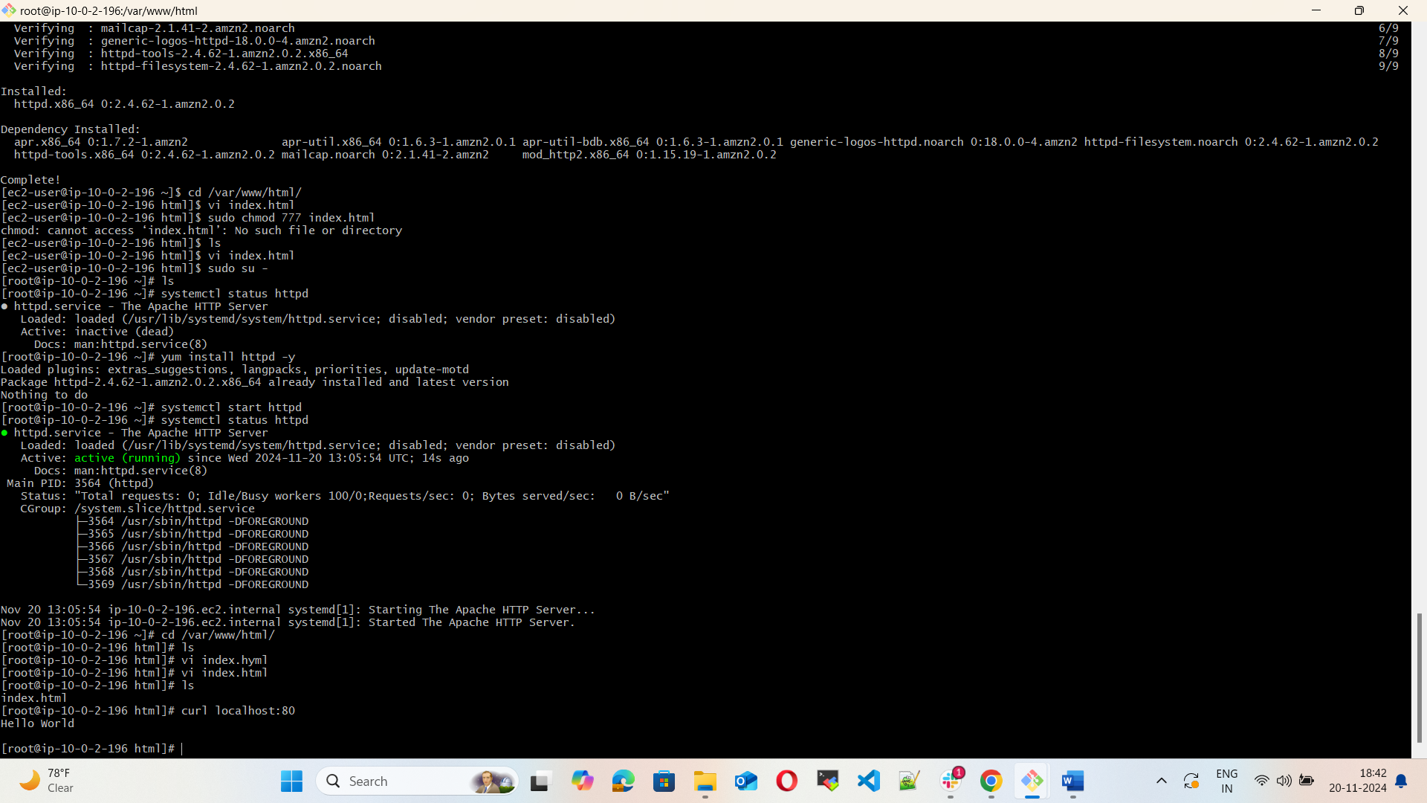

1. Create one application load balancer and attach the load balancer to both the ec2 instances.

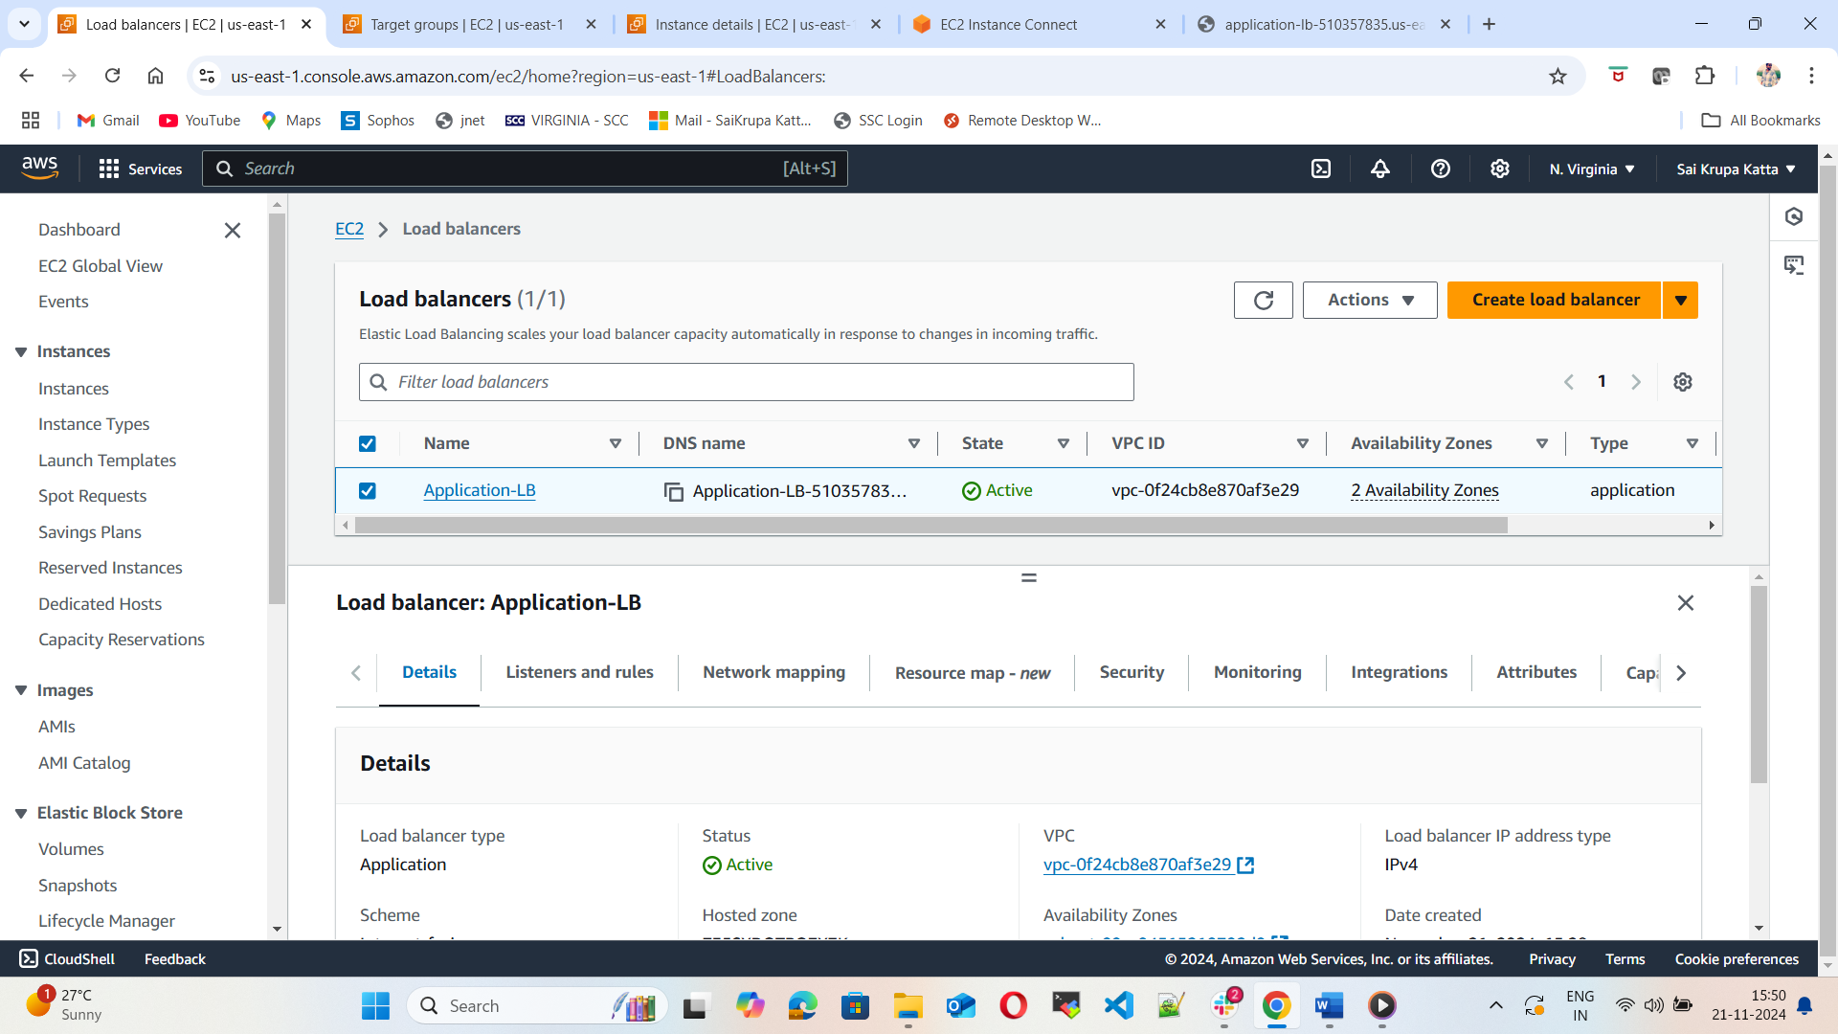

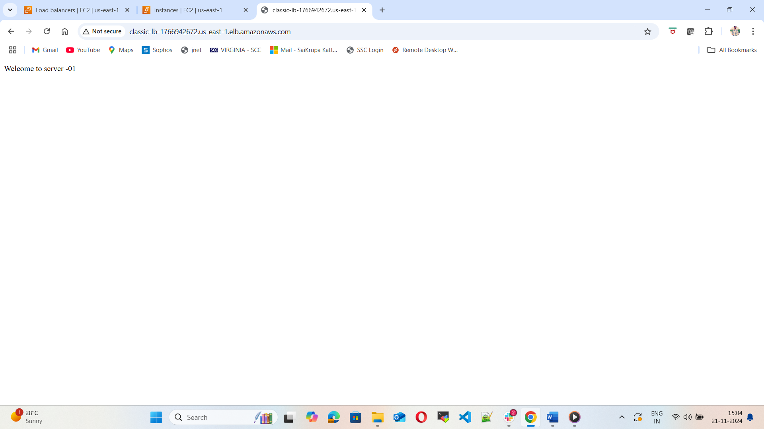

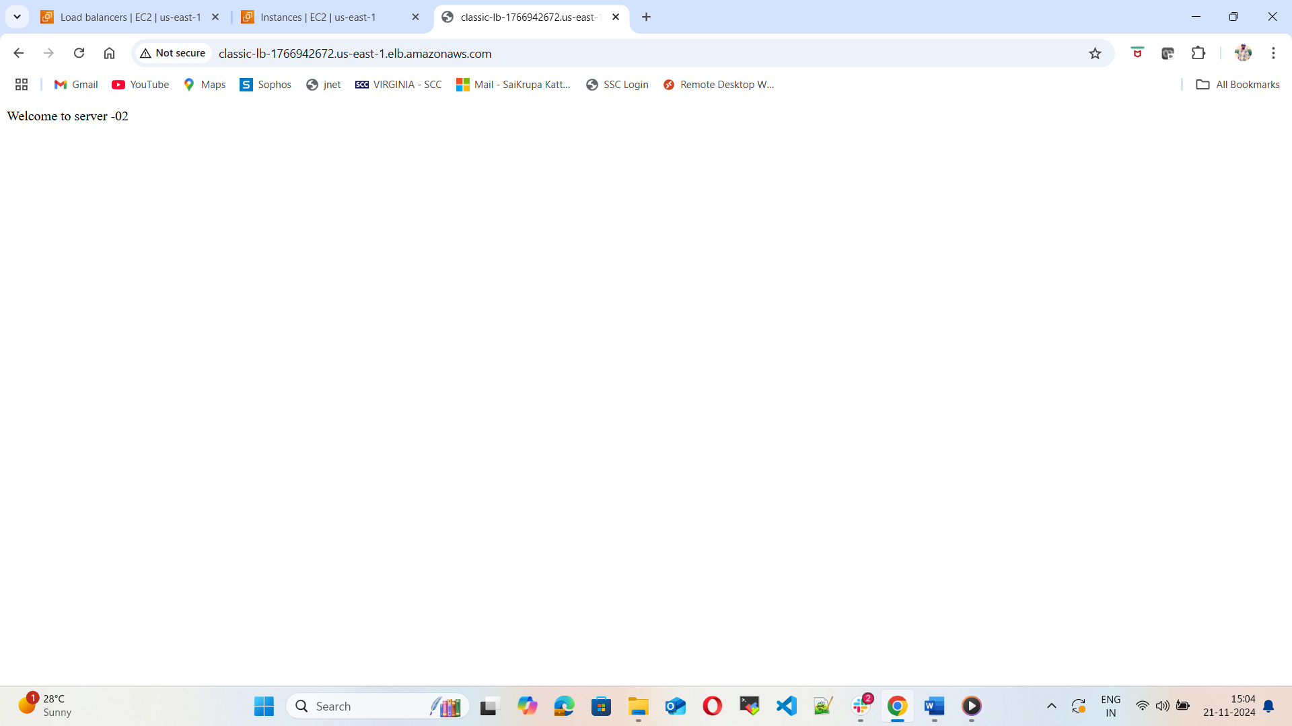

1. Store Application load balancer logs to s3.

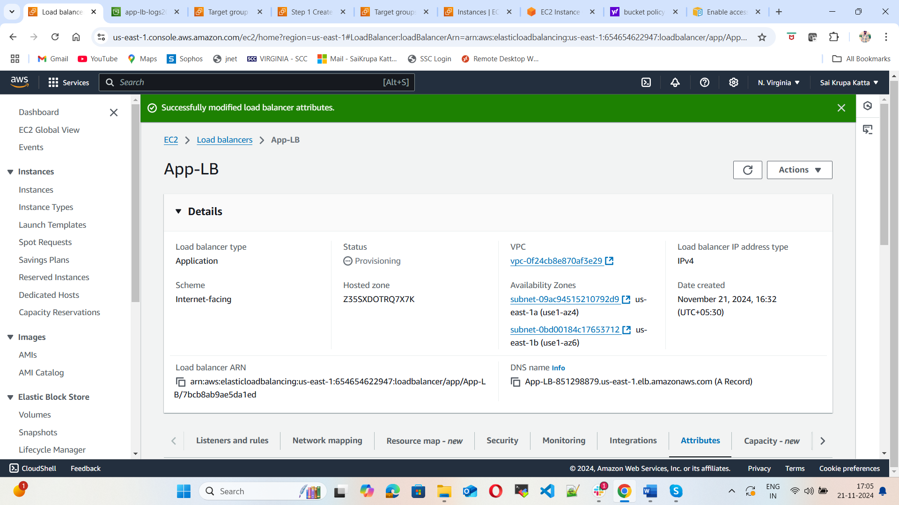

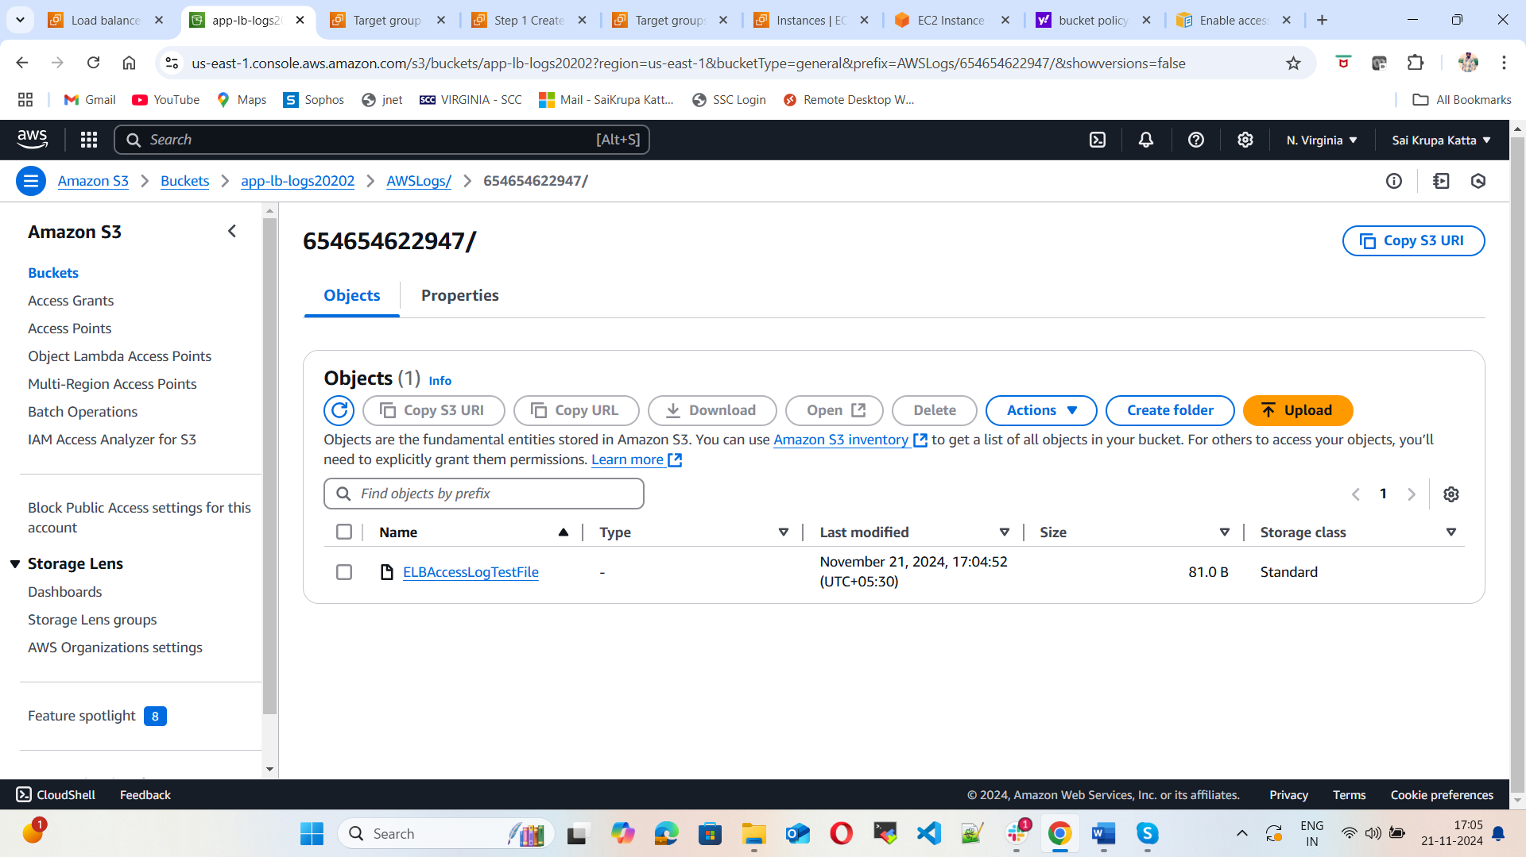

1. Store the vpc flow logs to CloudWatch group.

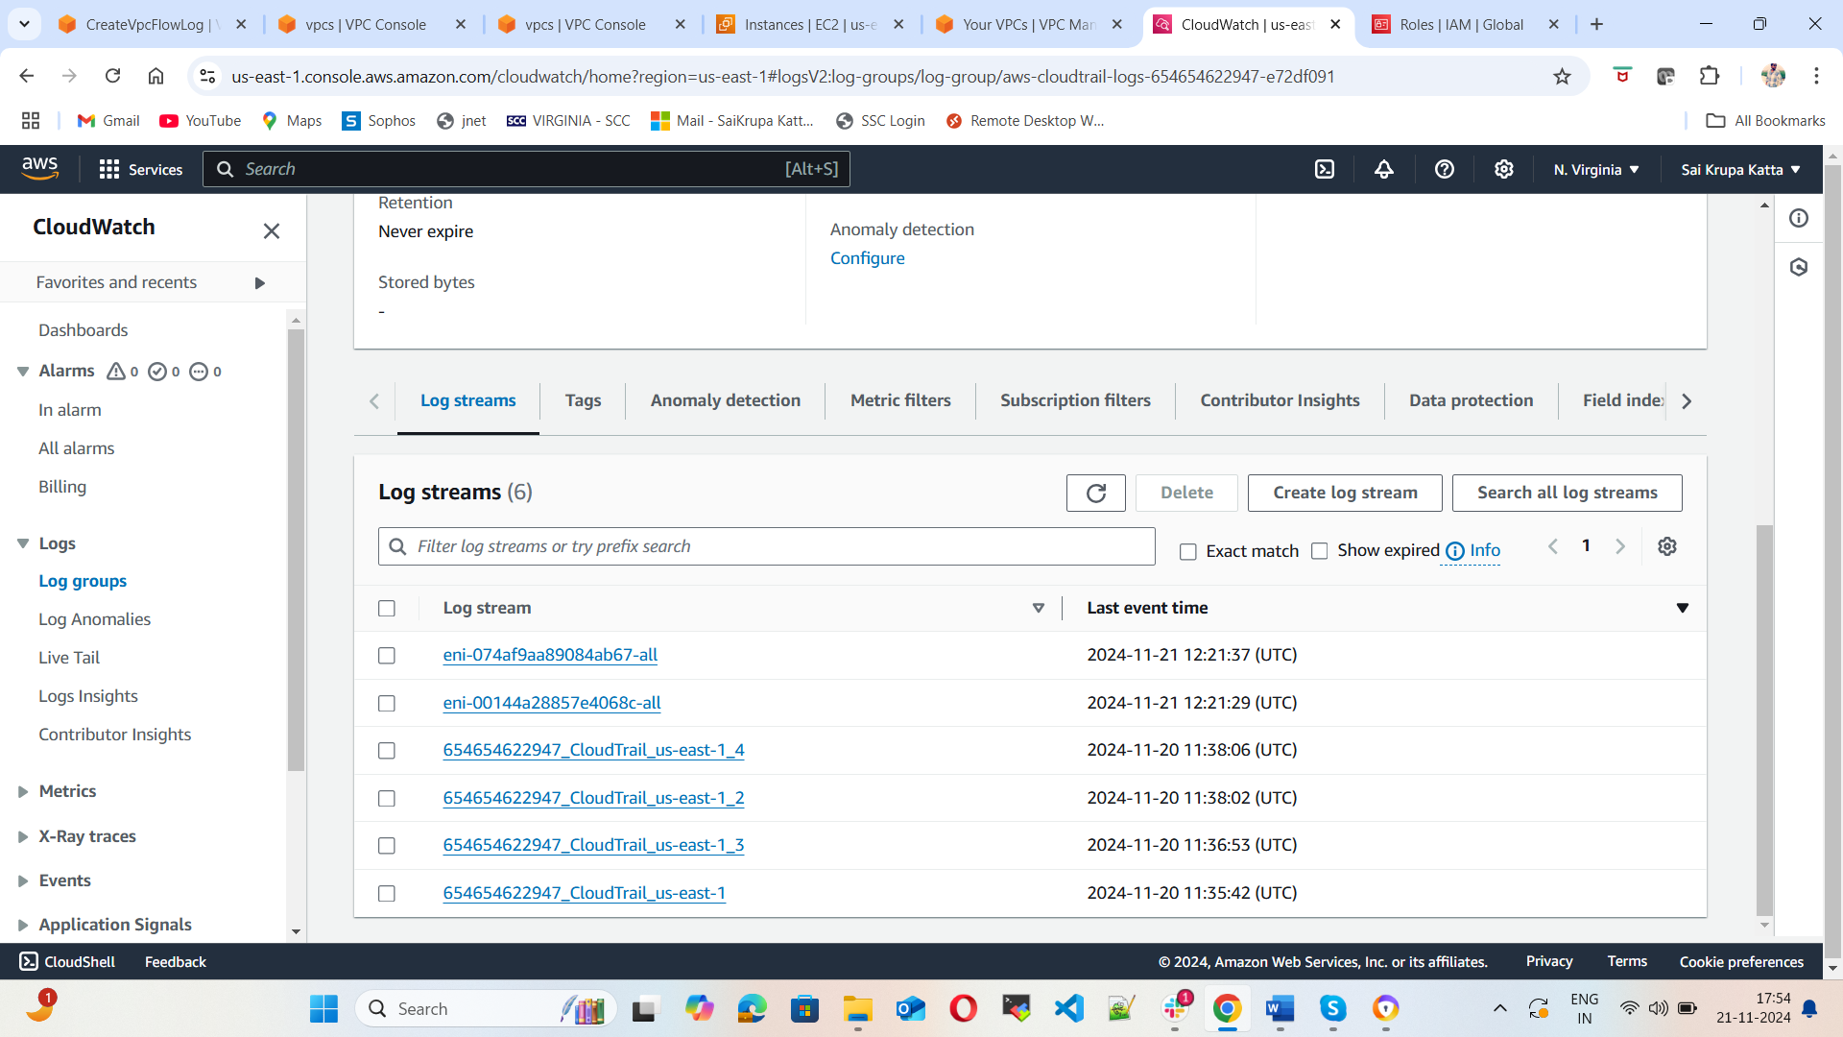

1. Create Monitoring Dashboards to monitor CPU utilization and to monitor Apache service.

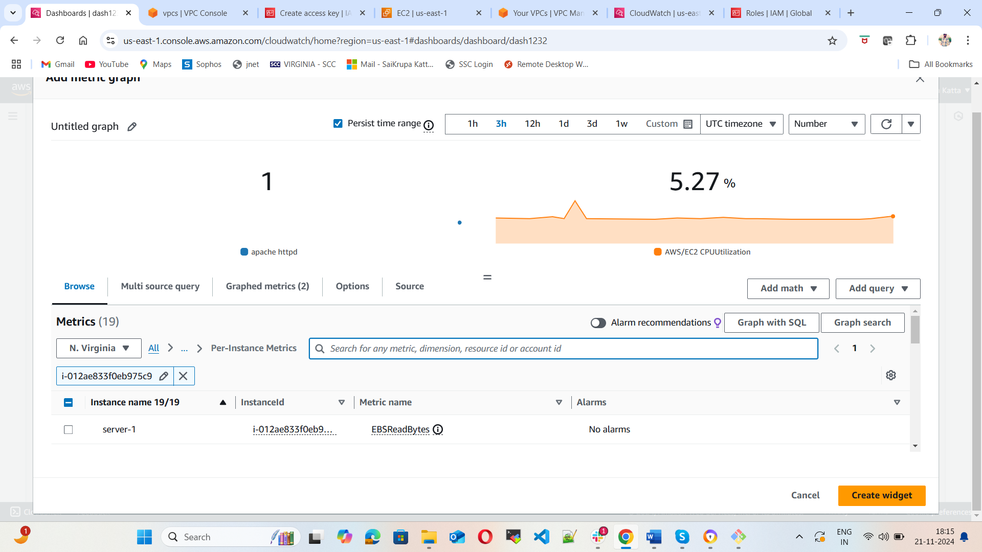

1. CPU utilization is more than 70% then it should trigger Autoscaling and launch new instance.

